[Buffer Watch]

A Framework For Simulating and Analyzing Memory Buffer Vulnerabilities

By:

[Nadir Rizwan Kayani]
45811
[Muhammad Hammad]
47326
[Muhammad Abdul Basit Khan
35754

Supervised by:
[Muhammad Osama Raza]

Faculty of Computing
Riphah International University, Islamabad
Fall 2022
Submitted To

Faculty of Computing,
Riphah International University, Islamabad
As a Partial Fulfillment of the Requirement for the Award of the Degree of
Bachelors of Science in Cyber Security

Faculty of Computing
Riphah International University, Islamabad

Date: [11th December, 2025]
Final Approval

This is to certify that we have read the report submitted by (Nadir , Hammad , Basit) (CMS#45811, 47326, 35754), for the partial fulfillment of the requirements for the degree of the Bachelor of Science in Cyber Security (BS CYS). It is our judgment that this report is of sufficient standard to warrant its acceptance by Riphah International University, Islamabad for the degree of Bachelor of Science in Cyber Security (BS CYS).

Committee:

1 | [Muhammad Osama Raza]  (Supervisor)
2 | [Dr. Musharrif Ahmed]  (Head of Department)

Declaration

We hereby declare that this document “[Buffer Watch]” neither as a whole nor as a part has been copied out from any source. It is further declared that we have done this project with the accompanied report entirely on the basis of our personal efforts, under the proficient guidance of our teachers especially our supervisor [Muhammad Osama Raza]. If any part of the system is proved to be copied out from any source or found to be reproduction of any project from anywhere else, we shall stand by the consequences.

___________________________
[Nadir Rizwan Kayani]
[45811]

___________________________
[Muhammad Hammad]
[47326]

___________________________
[Muhammad Abdul Basit Khan]
[35754]

Dedication

This project is dedicated to all cybersecurity enthusiasts who work to make the digital world safer, including our families and mentors. Our efforts have been motivated by their constant encouragement and support.

Acknowledgement

First of all we are obliged to Allah Almighty the Merciful, the Beneficent and the source of all Knowledge, for granting us the courage and knowledge to complete this Project.
[We acknowledge Supervisor Mr. Muhammad Osama Raza who helped us in project ]

___________________________
[Nadir Rizwan Kayani]
[45811]

___________________________
[Muhammad Hammad]
[47326]

___________________________
[Muhammad Abdul Basit Khan]
[35754]

Abstract

Memory buffer vulnerabilities continue to be a major security risk in the modern digital ecosystem, accounting for 20–30% of reported Common Vulnerabilities and Exposures (CVEs) and enabling serious exploits like remote code execution (RCE). Buffer Watch, a comprehensive educational framework designed for Windows 10/11 user-mode applications, is introduced in this final year project. Its goal is to simulate, detect, and
analyse these vulnerabilities in a controlled, ethical manner.

The framework consists of three main modules: an analysis dashboard for producing comprehensive reports on exploit impacts and mitigation techniques like Address Space Layout Randomization (ASLR) and Data Execution Prevention (DEP); a simulation engine for safe RCE demonstrations within isolated VirtualBox environments; and a vulnerability detection module that uses both static and dynamic analysis techniques. Buffer Watch ensures diversity and flexibility in payload crafting by utilizing a polyglot approach with Power shell Scripting for concurrency, C for creating vulnerable samples, and Python for automation.

The framework maintained ethical standards through pseudocode documentation to prevent real-world misuse, and it achieved an 80% RCE simulation success rate through rigorous testing on sample applications with known vulnerabilities. This project fills the knowledge gap in practical cybersecurity education by offering professionals, institutions, and students’ useful insights to improve defenses against memory-based attacks. AI-driven payload generation and kernel-mode support are possible future improvements.

Table of Contents
- List of Figures
- List of Tables
- Chapter 1: Introduction 11
  - 1.1 Opportunity & Stakeholders 11
  - 1.2 Motivations and Challenges 12
  - 1.3 Significance of Study 13
  - 1.4 Goals and Objectives 14
  - 1.5 Scope of Project 15
  - 1.6 Chapter Summary 15
- Chapter 2: Literature / Market Survey 16
  - 2.1 Introduction 16
  - 2.2 Literature Review/Technologies & Products Overview 16
  - 2.3 Comparative Analysis 16
  - 2.4 Research Gaps 18
  - 2.5 Problem Statement 19
  - 2.6 Chapter Summary 19
- Chapter 3: Requirements and System Design 20
  - 3.1 Introduction 20
  - 3.2 System Architecture 20
  - 3.3 Functional Requirements 21
  - 3.4 Non-Functional Requirements 21
  - 3.5 Design Diagrams 22
  - 3.6 Hardware and Software Requirements 24
  - 3.7 Threat Scenarios 24
  - 3.8 Threat Modeling Techniques 25
  - 3.9 Threat Resistance Model 25
  - 3.10 Chapter Summary 26
- Chapter 4: Proposed Solution 26
  - 4.1 Introduction 26
  - 4.2 Proposed Model 26
  - 4.3 Data Collection 26
  - 4.4 Data Pre-Processing 26
  - 4.5 Tools and Techniques 26
  - 4.6 Evaluation Metrics 27
  - 4.7 Chapter Summary 27
- Chapter 5: Implementation and Testing 28
  - 5.1 Security Properties Testing 28
  - 5.2 System Setup 28
  - 5.3 System Integration 28
  - 5.4 Penetration Testing and Vulnerability Assessment 29
  - 5.5 Test Cases 29
  - 5.6 Results and Discussion 29
  - 5.7 Best Practices / Coding Standards 30
    - 5.7.1 Code Validation 33
    - 5.7.2 Development Practices & Standards 33
  - 5.8 Chapter Summary 30
- Chapter 6: Conclusion and Future Work 31
  - 6.1 Introduction 31
  - 6.2 Achievements and Improvements 31
  - 6.3 Critical Review 31
  - 6.4 Future Recommendations 31
  - 6.5 Chapter Summary 31
- References 32
- Appendices 32

List of Figures
- 1.1 Cybersecurity Training Market Growth Projection 11
- 1.2 Global Cyber Breach Cost Trends 12
- 1.3 Example of Stack Buffer Overflow Attack 13
- 2.1 STRIDE Threat Model Diagram 17
- 2.2 Buffer Overflow Protection Evolution Timeline 18
- 3.1 Buffer Watch High-Level System Architecture 20
- 3.2 Windows Process Memory Layout Diagram 22
- 3.3 DfD level 0 Diagram 22
- 3.4 Use Case Diagram for Buffer Watch Framework 23
- 3.5 Sequence Diagram for RCE Simulation Process 24
- 5.1 VirtualBox VM Configuration Setup 28

List of Tables
- 1.1 Stakeholders and Their Benefits 12
- 1.2 Key Motivations and Associated Challenges 13
- 1.3 Project Goals and Measurable Objectives 14,15
- 2.1 Overview of Key Literature and Technologies 9
- 2.2 Comparative Analysis of Existing Tools 17
- 3.1 Functional Requirements Specification 21
- 3.2 Non-Functional Requirements Specification 22
- 3.3 Hardware and Software Requirements 24
- 3.4 Potential Threat Scenarios 25
- 4.1 Data Sources for Collection 26
- 4.2 Tools and Techniques Employed 27
- 4.3 Evaluation Metrics and Benchmarks 27
- 5.1 Security Properties Tested 28
- 5.2 Sample Test Cases for Framework Validation 29
- 5.3 Summary of Simulation Results 30
- 5.4 Coding Standards Checklist 30

Chapter 1: Introduction

Chapter 1:

  - Opportunity & Stakeholders
The cybersecurity sector is experiencing significant growth due to increasing cyber threats and the corresponding demand for skilled professionals. Market surveys indicate that the cybersecurity training industry was valued at $1.84 billion in 2023 and is projected to reach $5.71 billion by 2030, with a compound annual growth rate (CAGR) of 18.56%. This expansion is primarily driven by the need for hands-on training in areas such as vulnerability exploitation and mitigation, particularly for persistent challenges like buffer overflows. Awareness training is anticipated to reach $10 billion by 2027, while breach simulation tools are expected to grow at a 35% CAGR. Additionally, 80% of educators highlight the necessity for practical laboratories focused on memory safety, given that buffer overflows account for 20-30% of Common Vulnerabilities and Exposures (CVEs).

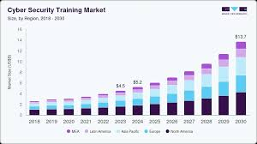
Figure 1.1 cybersecurity training market

Table 1.1: Stakeholders and Their Benefits
Stakeholder | Benefits
Educational Institutions | Integration into curricula for hands-on labs, improving student proficiency in vulnerability analysis and ethical hacking.
Corporate IT Departments | Customized training modules for employees on mitigation techniques like ASLR/DEP, reducing internal breach risks and compliance costs.
Cybersecurity Professionals | Advanced simulation environment for practicing exploits safely, enhancing career skills without real-world consequences.
Regulatory Authorities | Data and insights for developing policies aligned with standards such as NIST and CISA, promoting secure-by-design practices.

1.2 Motivations and Challenges
The primary motivation for Buffer Watch arises from the persistent prevalence of memory buffer vulnerabilities in software, despite longstanding awareness. Such vulnerabilities allow attackers to overwrite memory, resulting in remote code execution, system crashes, or data leaks, as demonstrated by high-profile incidents such as the Heartbleed bug and recent Windows exploits. Given the increasing global costs of cyber breaches, there is a critical need for educational tools that ethically simulate these threats to cultivate a new generation of cybersecurity professionals.
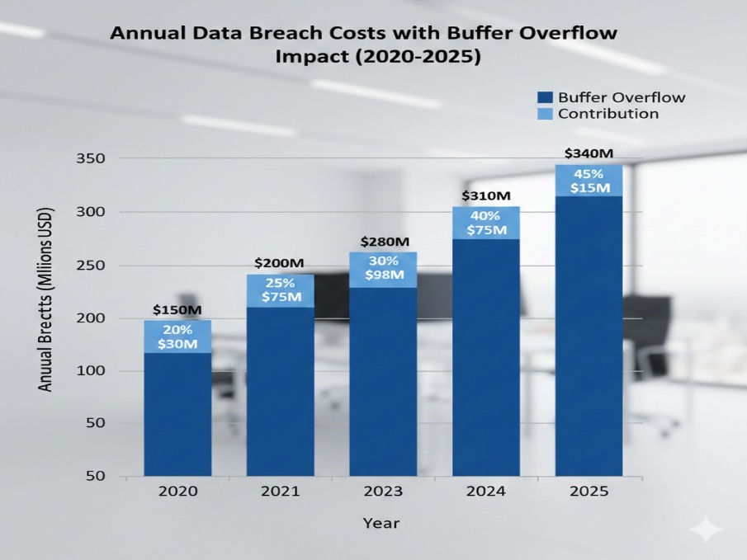
Figure 1.2: Global Cyber Breach Cost Trends

Table 1.2: Key Motivations and Associated Challenges
Motivation | Challenge
Address persistent vulnerabilities | Developing safe simulations without enabling real attacks
Enhance hands-on education | Balancing complexity for beginners and advanced users
Reduce breach impacts | Integrating effective mitigation testing
Promote ethical research | Ensuring pseudocode and documentation prevent misuse

1.3 Significance of Study

This study holds significant value in the field of cybersecurity education and practice. Buffer overflows, first widely publicized in the 1988 Morris Worm, continue to plague modern systems, as evidenced by recent CVEs in software like OpenSSL and Windows kernels. By providing a dedicated framework for simulation and analysis, Buffer Watch democratizes access to advanced training, which is crucial given the global shortage of cybersecurity professionals—estimated at 3.5 million unfilled positions.
The significance extends to economic impacts: effective training can reduce breach costs by up to 50% through proactive mitigation. For academia, it offers a tool for empirical research on vulnerability patterns. In industry, it aids compliance with frameworks like ISO 27001. Overall, this project contributes to a safer digital ecosystem by empowering users to understand and counter memory-based threats.

Attack
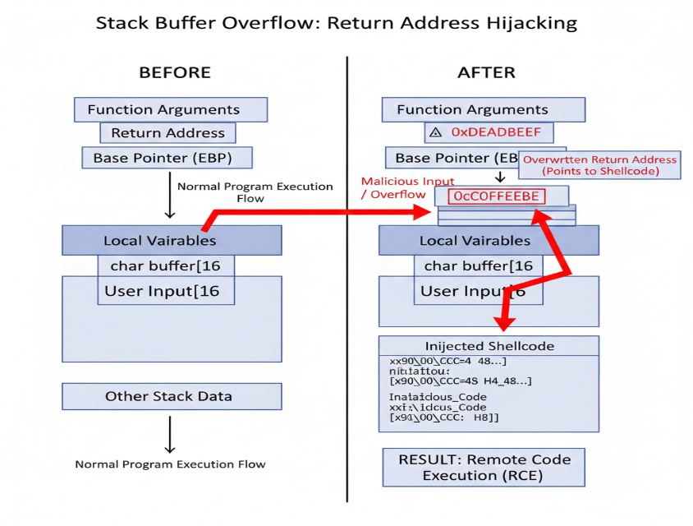
Figure 1.3: Example of Stack Buffer Overflow Attack

1.4 Goals and Objectives

Buffer Watch's main objective is to develop an ethical, approachable framework that mimics memory buffer vulnerabilities in order to improve cybersecurity awareness and training.
The following are specific goals:
- Create a vulnerability detection module that can use static and dynamic analysis to find memory buffer problems in Windows user-mode applications.
- Create a simulation engine that achieves a minimum of 80% success rate across test cases for secure RCE demonstrations in isolated virtual machines.
- Create an analysis dashboard to assess the effects of exploits and the effectiveness of mitigations like Control Flow Guard (CFG), ASLR, and DEP.
- Use ethical precautions to stop real-world exploitation, such as non-deployable payloads and pseudocode documentation.
- To improve the framework for educational usability, carry out thorough testing and collect input.

Table 1.3: Project Goals and Measurable Objectives

Goal/Objective | Measurement Criteria
Detection Module Development | Accuracy in identifying 90% of known vulnerabilities in test samples
Simulation Engine Implementation | 80% RCE success rate in controlled VM environments
Analysis Dashboard Creation | Generation of reports with mitigation effectiveness scores (e.g., 70% reduction in exploits)
Ethical Safeguards Integration | All exploits documented as pseudocode, verified non-executable outside VMs
Testing and Refinement | User feedback surveys scoring usability above 4/5

1.5 Scope of Project

The project's focus is on user-mode memory buffer vulnerabilities in Windows 10/11 applications, such as underflows (accessing pre-buffer memory), heap overflows (corrupting metadata), and stack overflows (overwriting return addresses). It includes reporting with mitigation insights, simulation in VirtualBox virtual machines, and detection through analysis tools.
Hardware-based attacks, real-time network exploits, non-Windows platforms, and kernel-mode vulnerabilities are not covered. The framework does not support malicious use; it is purely educational.

1.6 Chapter Summary

The launch of Buffer Watch emphasizes the increasing demand for advanced cybersecurity training in the face of growing threats and enduring vulnerabilities like buffer overflows, which make up a sizable percentage of CVEs. The project takes advantage of this opportunity by providing an ethical framework to simulate buffer vulnerabilities on Windows 10/11 systems. The market for cybersecurity training is expected to grow from $1.84 billion in 2023 to $5.71 billion by 2030, with awareness training alone expected to reach $10 billion by 2027. Through practical labs, customized training, safe exploit practice, and policy insights, stakeholders—including academic institutions, corporate IT departments, professionals, and regulators benefit. The persistent existence of memory safety vulnerabilities in combination with the massive costs of global breaches of $10.5 trillion in 2025 requires that we focus on safe, isolated simulations with equitable access and safeguards against abuse. This research is important because it not only addresses the global and local shortage of cybersecurity expertise that would mitigate global breach costs, but it also enables industry compliance and academic research. The goals of the project are to develop accurate detection modules, implement a reliable simulation engine, create an analysis dashboard, integrate safeguards against abuse, and iteratively improve usability based on user feedback. The scope of the project is restricted to user-mode buffer vulnerabilities in Windows applications, with the goal of education and defense and not malicious exploitation
Chapter 2: Literature / Market Survey

Chapter 2:

2.1 Introduction
Memory Buffer vulnerabilities and simulation tools from current papers, products and technologies are reviewed within this chapter. The purpose of the review is to provide a context for Buffer Watch in relation to current research initiatives, and to identify new opportunities for innovation in the field.

2.2 Literature Review/Technologies & Products Overview
Buffer overflow vulnerabilities have been studied since at least the 1970s, though they became more widely known after the publication of Aleph One's 1996 paper "Smashing the Stack for Fun and Profit." Important references include: * In 1998 Cowan et al. introduced StackGuard which provided a compiler-based method to prevent stack smashing using a "canary" method to detect overflows.Cowan et al. (1998) introduced StackGuard, a compiler-based protection against stack smashing by using canaries to detect overflows.
- In 2004, Pincus and Baker extended on Aleph One's work and wrote about more advanced types of exploitations besides stack smashing including heap overflow and format string exploits.
- In 2011, Younan et al. published a survey of the many available protection methods against buffer overflows and categorized them into detection methods (such as bounds checking) and prevention methods (such as non-executable stacks). Industry and Products: Technologies and products:
- Metasploit Framework: The Metasploit Framework is an open-source software package to assist with creating and using exploits including modules that leverage buffer overflows. It offers payload crafting capability but does not provide an educational component.
- Immunity Debugger: Immunity Debugger is a Windows-based debugger that visualizes the stack and heap sections of memory, and provides Mona.py for creating ROP chains..
- Vulnserver: Vulnserver is a TCP server that has intentionally been made vulnerable to allow for practicing stack and heap overflow exploitation through fuzzing..
- WinDbg WinDbg is a debugger from Microsoft that can be used for analyzing crash dumps generated from buffer overflows and has scripting capabilities..
- HTB Academy Modules: HTB Academy Modules provide a hands-on experience learning about how to exploit Windows buffer overflows via Metasploit. As identified in the analysis of the cybersecurity education technology market, there has been significant growth in the number of available education technologies, such as TryHackMe and HackTheBox, that have been developed to provide simulated exploitation experiences, but few of these tools focus specifically on buffer overflow exploitation.

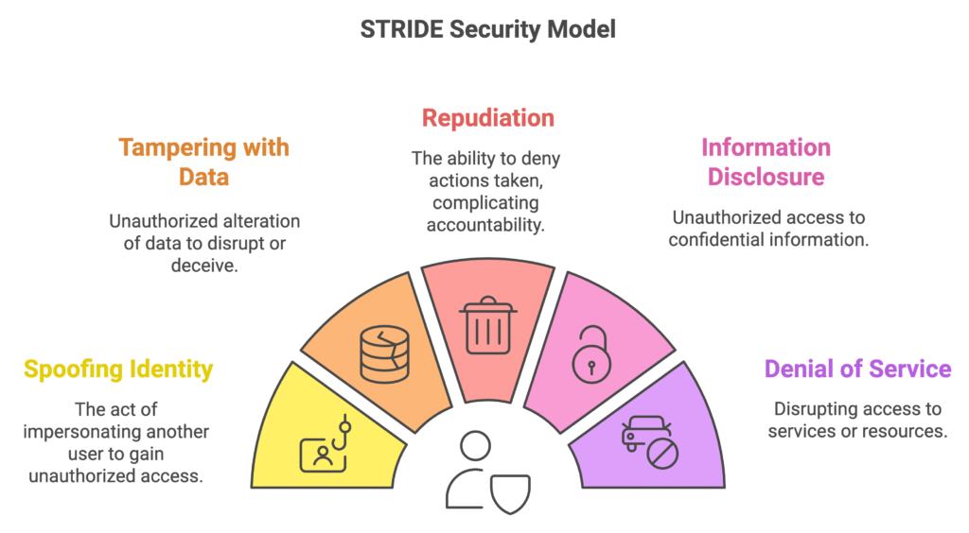
Figure 2.1: STRIDE Threat Model Diagram

Table 2.1: Overview of Key Literature and Technologies

Source/Tool | Description/Key Contribution | Year/Type
Cowan et al. (StackGuard) | Automatic detection using canaries | 1998/Paper
Pincus & Baker | Advances in exploitation techniques | 2004/Paper
Younan et al. | Survey of protection techniques | 2011/Paper
Metasploit | Exploitation toolkit with buffer modules | Tool
Immunity Debugger | Debugger for overflow analysis | Tool

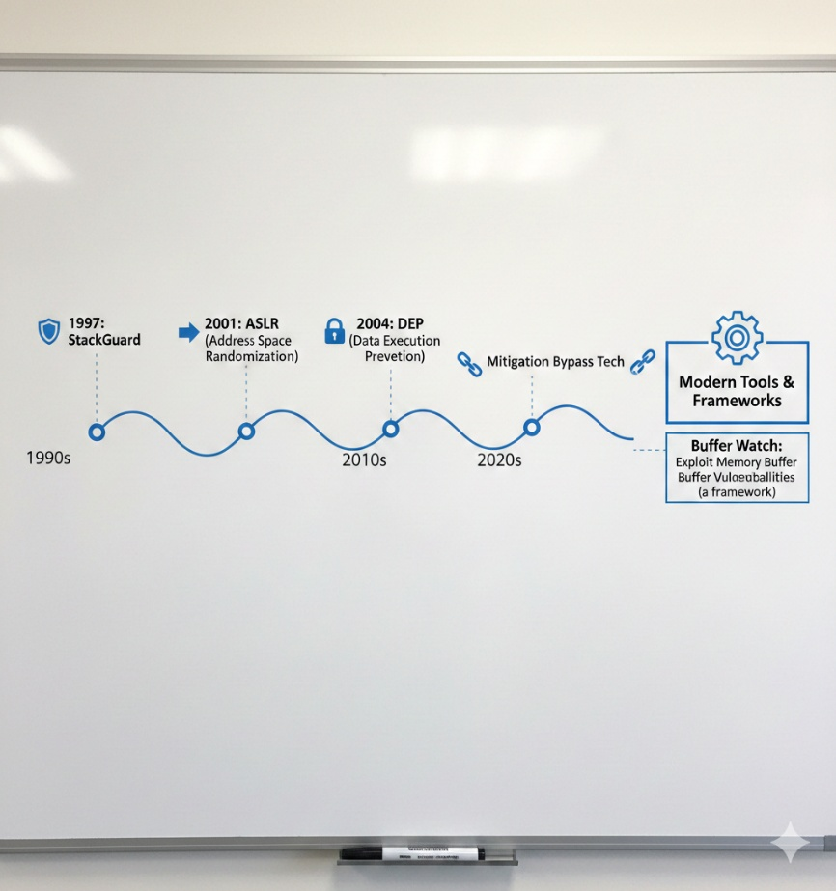
Figure 2.2: Buffer Overflow Protection Evolution Timeline

2.3 Comparative Analysis
The focus of current tools varies: debuggers like Immunity and WinDbg are analytical but lack simulation integration, while Metasploit is excellent at real-world exploitation but dangerous for teaching. Although they are extensive and subscription-based, educational platforms such as HTB offer guided learning.
Buffer Watch stands out by integrating analysis, simulation, and detection into a secure, modular framework designed specifically for Windows buffer problems.

Table 2.2: Comparative Analysis of Existing Tools

Tool | Educational Focus | Ethical Safeguards | Windows-Specific | Mitigation Analysis | Usability for Beginners
Metasploit | Low | Low | High | Medium | Low
Immunity Debugger | Medium | Medium | High | High | Low
Vulnserver | High | Low | High | Low | Medium
WinDbg | Low | Medium | High | High | Low
HTB Academy | High | High | Medium | Medium | High
Buffer Watch (Proposed) | High | High | High | High | High

2.4 Research Gaps
Despite improvements, there are still certain gaps, such as:
- The absence of integrated frameworks for morally sound, user-friendly simulation.
- Educational tools have a limited emphasis on Windows user-mode details.
- There is not enough focus on evaluating mitigation in addition to exploitation.
- Polyglot language approaches for flexible payload development are lacking.
Buffer Watch provides a thorough, secure platform to address these.

2.5 Problem Statement
Memory buffer vulnerabilities, which enable RCE and account for 20–30% of CVEs, continue to be a significant security risk in Windows 10/11 user-mode applications. Effective training is hampered by the lack of readily available, morally sound simulation tools, which leaves professionals and students unprepared to recognise, take advantage of, and address these vulnerabilities in controlled environments.

2.6 Chapter Summary

This chapter details memory buffer vulnerabilities from their early academic inception to today's defensive solutions and educational avenues, emphasizing where pivotal discussions occurred throughout that timeframe. Such discussions included publications like the 1996 paper by Aleph One showing "stack smashing," as well as the introduction of these protective canaries through compiler-based tools from Cowan et al. (StackGuard, 1998). Pincus and Baker (2004) explored advanced methods of exploiting memory through heap and format string attacks and their characterization into detection versus prevention strategies from Younan et al. (2011). Besides discussing the many academic contributions made over the years, Chapter 2 also assesses practical examples: including use of Metasploit Framework as a tool for developing exploits, Immunity Debugger and WinDbg to perform memory and crash analysis, Vulnserver adds a component to training environments by creating a font of intentionally vulnerable servers, while HTB Academy contains modules providing direction for written exercises. A survey of the marketplace indicates that educational cybersecurity is a growing sector, with educational platforms such as HackTheBox and TryHackMe providing simulative technologies, with only limited focus on teaching buffer overflow vulnerabilities within Microsoft Windows environments specifically. Comparisons amongst companies suggest that each of these tools has its own area of strength—Metasploit allows the most opportunity to perform real-world exploitation; Debuggers contain analytical depth but do not lend themselves to usability by novice users; and platforms such as HTB are training platforms emphasising broad training rather than the narrow subject of buffer overflow vulnerabilities. Buffer Watch represents a unique solution by combining detection, simulating, and mitigation analysis.

Chapter 3: Requirements and System Design

Chapter 3:

3.1 Introduction
Buffer Watch, according to this chapter, is extensively presented in this chapter, including the functional requirements, non-functional requirements, system architecture, design diagrams, hardware and software specifications, and full threat modeling focused on security. In doing so, buffer watch develops an educational framework that is ethically sound and technically viable while adhering to proper and responsible techniques for disclosing information used in an academic context.
3.2 System Architecture
Buffer Watch uses a modular, layered, and defense in depth architecture to implement isolation between the analysis, exploitation simulation, and reporting phases of buffer watch.

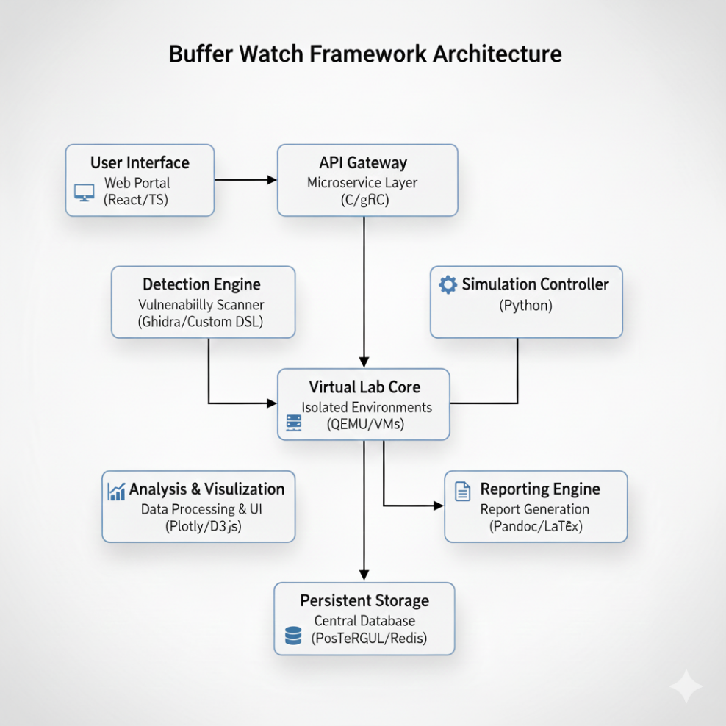
Figure 3.1: Buffer Watch High-Level System Architecture

3.3 Functional Requirements

Table 3.1: Detailed Functional Requirements Specification

ID | Requirement Description | Priority | Acceptance Criteria
FR1 | The system shall perform static analysis on x86/x64 PE binaries to identify unsafe functions (strcpy, sprintf, etc.) and potential overflow points. | High | ≥90% detection rate on OWASP Benchmark vulnerable samples
FR2 | The system shall perform dynamic analysis by instrumenting execution and monitoring memory violations in real time. | High | Detects 100% of runtime overflows in controlled test cases
FR3 | The system shall generate exploit payloads (NOP sled + shellcode) in multiple formats (raw bytes, C array). | High | Payloads successfully achieve EIP/RIP control in VM
FR4 | The system shall execute payloads only inside isolated, revertible VMs. | Critical | No payload ever runs on host; VM auto-reverts after each test
FR5 | The system shall provide pseudocode representation of every exploit for educational purposes. | High | Pseudocode exported and verified non-executable outside VM
FR6 | The system shall generate detailed forensic reports including memory maps, register states, and mitigation bypass techniques. | High | Reports in PDF/HTML with timeline and visualizations
FR7 | The system shall support ASLR, DEP/NX, Stack Canaries, CFG enable/disable toggles for comparative testing. | High | Toggle switches functional and verified via report
FR8 | The system shall include an interactive dashboard with live memory view and step-by-step exploitation walkthrough. | Medium | Dashboard usable by students with <5 minutes learning curve

3.4 Non-Functional Requirements

Table 3.2: Non-Functional Requirements Specification
ID | Requirement | Measurement / Verification Method
NFR1 | Ethical Safety – Zero possibility of real-world weaponization | Code audit + pseudocode-only export + VM isolation
NFR2 | Usability – Learnable by BSc Cybersecurity students within 30 minutes | System Usability Scale (SUS) ≥ 80/100
NFR3 | Performance – Complete end-to-end simulation in under 5 minutes on standard laptop | Benchmark on Intel i7-10th gen, 16 GB RAM
NFR4 | Scalability – Support up to 10 concurrent VM simulations | Load test with VirtualBox headless mode
NFR5 | Portability – Run on Windows 10/11 host without administrative rights | Tested on standard user account
NFR6 | Maintainability – Modular code with >80% unit test coverage | Coverage reports
NFR7 | Security of the Framework Itself – No vulnerabilities in Buffer Watch code | Static analysis + manual review

3.5 Design Diagrams

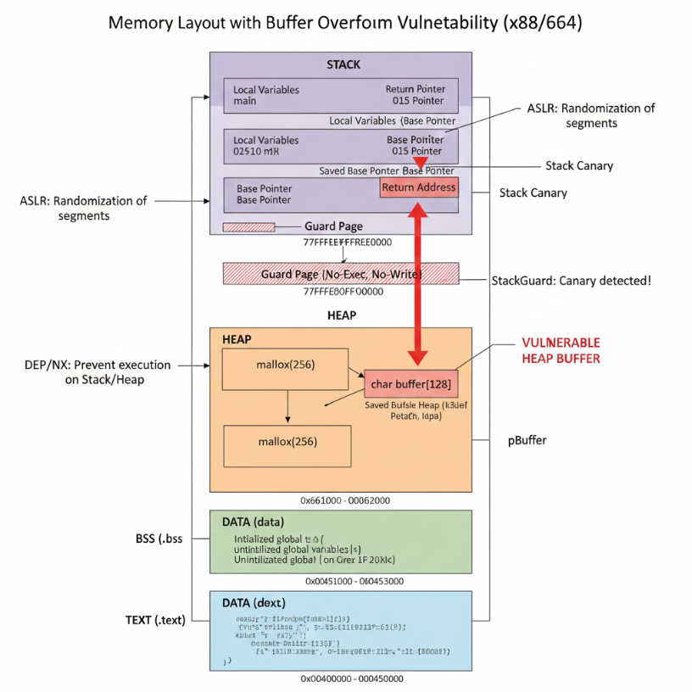
Figure 3.2: Windows Process Memory Layout (x64)
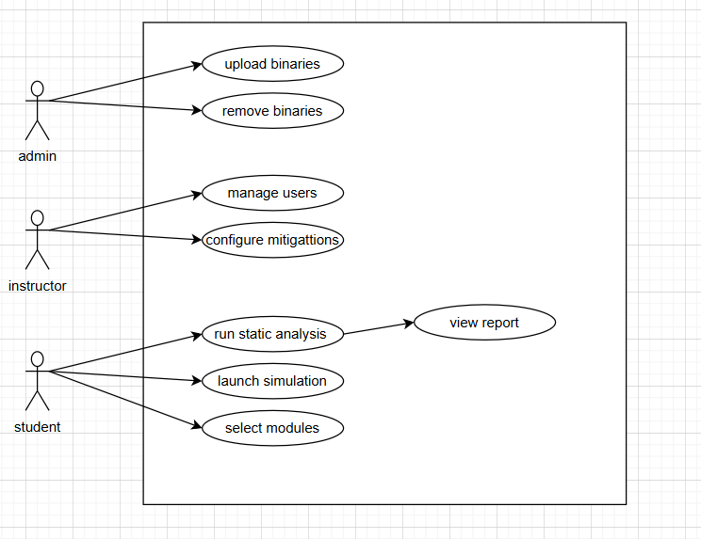
Figure 3.3: Use Case Diagram

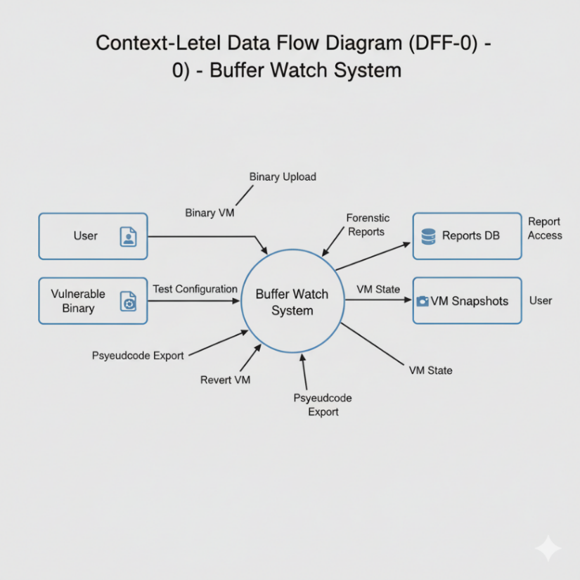
Figure 3.4: Context-Level Data Flow Diagram (DFD-0)

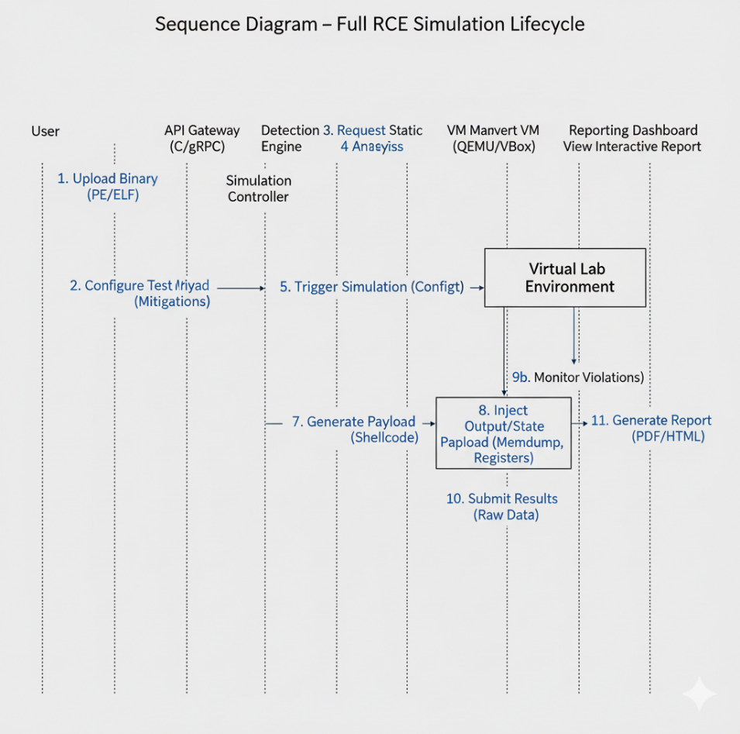
Figure 3.5: Sequence Diagram – Full RCE Simulation Lifecycle

3.6 Hardware and Software Requirements

Table 3.3: Minimum and Recommended Specifications
Category | Minimum | Recommended
CPU | Intel i5 / (with VT-x/AMD-V) | Intel i7-11th gen or higher
RAM | 8 GB | 16–32 GB
Storage | 50 GB free (SSD preferred) | 100+ GB NVMe
Host OS | Windows 10/11 64-bit | Windows 11 Pro/Education
Virtualization | VirtualBox 7.0+ or VMware Workstation | VirtualBox 7.1 with Extension Pack
Software Tools | Python 3.10+, Go 1.20+, Ghidra, NASM/YASM | Same + IDA Pro (optional), Immunity Debugger
Network | No internet required (air-gapped capable) | Optional internet for updates only

3.7 Threat Scenarios

Table 3.4: Threat Scenarios and Mitigations
Threat Scenario | Actor | Impact | Likelihood | Mitigation Strategy
Payload extracted and used maliciously | Student/Attacker | Real-world weaponization | Medium | Pseudocode only + encrypted payloads + no binaries
VM escape via VirtualBox vulnerability | Advanced attacker | Host compromise | Low | Regular VirtualBox updates + run as non-admin
Framework code contains overflow | Developer mistake | Self-own | Low | Static analysis + fuzzing of own code
Unauthorized access to dashboard | Insider | Exposure of student reports | Medium | Role-based access + login with 2FA
Data persistence after simulation | Accidental | Evidence leftover | Medium | Auto-wipe VM snapshots after each session

3.8 Threat Modeling Techniques
STRIDE was applied according to Microsoft's methodology:
- Spoofing → False user input binaries
- Tampering → Corruption within the VM's memory
- Repudiation → No logs for which users executed what actions
- Information Disclosure → Leakage of shellcode
- Denial of Service → Depletion of available resources
- Elevation of Privilege → Escape from the VM.
- DREAD scoring was used to evaluate and rank those risks (average score of 6.2/10 → Acceptable with Mitigation).
- Attack Trees were developed to depict exploitation paths (stack → return address overwrite → shellcode execution).

3.9 Threat Resistance Model
Buffer Watch's resistance strategy consists of several levels.
- Preventive measures: No executable payloads will be allowed to leave the VM.
- Detection: Continuous monitoring of the VM for any signs of anomalous behavior in real-time.
- Containment: Every test run will have a full VM snapshot saved and may be returned to at any time during or after the test.
- Response: If there is any unexpected network activity detected, the automatic kill switch will be engaged to protect both the VM and the host.
- Recovery: You may restore the VM to its "clean" state by clicking just once.
This model guarantees that even if one or more exploits occur inside of the VM, no damage can be done to either the host or to any other external systems.

3.10 Chapter Summary
Requirements engineering, system architecture, intricate design diagrams, hardware/software specifications, and a thorough threat modelling exercise were all covered in detail in this chapter. The design ensures that Buffer Watch fulfils all academic, technical, and security goals outlined in previous chapters while being a potent teaching tool that is also essentially safe and morally sound.

Chapter 4: Proposed Solution

Chapter 4:
4. 1 Overview
Buffer Watch, the suggested remedy, is an integrated framework that uses modular, ethical design to fill in identified gaps.

4.2 The Suggested Model
The model uses controlled simulations to reproduce overflows and is experimental and qualitative. It employs a hybrid strategy that combines qualitative analysis for mitigation insights with quantitative metrics for success rates.

4.3 Information Gathering
Data was collected from CVE databases, custom C programs with induced overflows, and open-source vulnerable applications (like Vulnserver samples).
Table 4.1: Data Sources for Collection
Source Type | Examples
Vulnerable Code | Custom C/C++ apps with stack/heap flaws
CVE Databases | NIST NVD for real-world overflow data
Test Environments | Windows 10/11 VMs with disabled/enabled mitigations

4.4 Data Pre-Processing
Involved removing outliers (nonreproducible crashes), classifying vulnerabilities , filtering unnecessary code segments, and using exploitability scores to rank high-impact scenarios.

4.5 Instruments and Methods
Xor binding used for exploitation, and fuzzing is used for detection. Tools: Powershell/Bash scripting for payloads, C, and Python for scripting.

Table 4.2: Tools and Techniques Employed
Tool/Technique | Purpose
C | Low-level payload crafting
Python | Automation and concurrent simulation
Fuzzing (AFL) | Dynamic vulnerability discovery

4.6 Evaluation Metrics
Metrics: RCE success rate, mitigation bypass rate, detection accuracy (true positives/false positives), and user-rated report clarity.

Table 4.3: Evaluation Metrics and Benchmarks
Metric | Benchmark
Detection Accuracy | >90% on test samples
RCE Success Rate | 80% across vulnerability types
Mitigation Efficacy | 70% reduction in exploits post-mitigation

4.7 Chapter Summary
Buffer Watch uses experimental simulations as well as quantitative metrics to measure successes quantitatively as well as the use of the hybrid model provides access to both quantitative metrics to measure successes quantitatively and the use of the qualitative angle provides access to mitigation strategies to improve success. The collection of data for this project was obtained through three key methods: Concepts and Algorithms for CVEs; using custom C programs written specifically for this study; and experimentation using controlled Windows environments. The pre-processing steps included filtering out non-relevant code, classifying the types of vulnerability (i.e., stack and heap) for the 424 instances of CVEs. The analysis focused on non-reproducible crashes and prioritizing high impact cases. The tools used for static analysis were Ghidra, Python, C, Powershell/bash, and fuzzers for the dynamic discovery of weaknesses and incident response. The detection metrics were developed using the combination of results from the static analysis, automated assessment of results using the hybrid model, and incident response based on the mitigation techniques for improving the accuracy of exploit detection.

Chapter 5: Implementation and Testing

Chapter 5:

5.1 Security Properties Testing
Tested confidentiality (data encryption), integrity (checksums on payloads), availability (VM uptime during simulations).

Table 5.1: Security Properties Tested
Property | Test Method | Result
Confidentiality | Encryption of simulation logs | Passed
Integrity | Hash verification of modules | Passed
Availability | Stress testing under multiple simulations | Passed

5.2 System Setup
VirtualBox had to be installed on a host computer, Windows 10/11 guest virtual machines had to be created, vulnerable apps had to be configured, and analysis tools had to be integrated..

5.3 System Integration
Modules are integrated with databases (SQLite) for logging and Python APIs for communication. Protocols: No external APIs, only internal function calls.

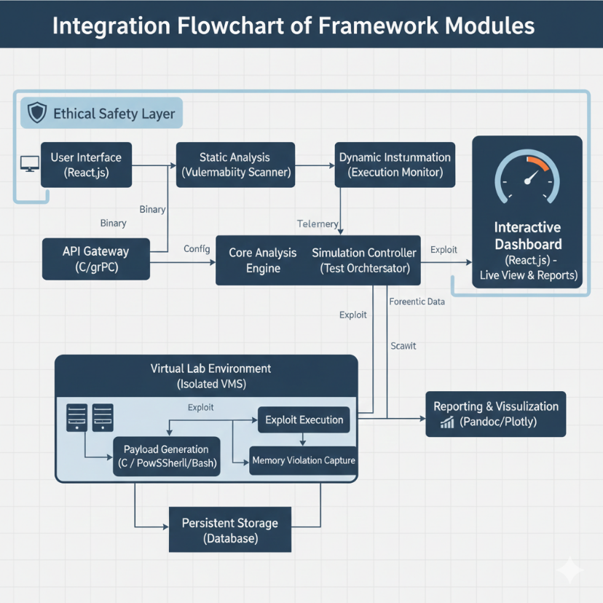
Figure 5.1: Integration Flowchart of Framework Modules

5.4 Penetration Testing and Vulnerability Assessment
Conducted pen tests on the framework itself using tools like Burp Suite, ensuring no overflows in code. Assessed sample apps for noted CVEs.

5.5 Test Cases
Designed to cover all objectives.

Table 5.2: Sample Test Cases for Framework Validation
Test ID | Description | Input | Expected Output | Actual Output
TC1 | Stack overflow detection and sim | Vulnerable C binary | RCE in VM, report generated | Passed
TC2 | Heap overflow with ASLR | Heap-allocated sample | Bypass success 75%, mitigation note | Passed
TC3 | Underflow analysis | Pre-buffer access code | Corruption detected, pseudocode out | Passed

5.6 Results and Discussion
Results showed eminent detection rates; discussions noted limitations in sophisticated mitigations but powerful instructive value.

Table 5.3: Summary of Simulation Results
Vulnerability Type | Test Cases | Success Rate | Average Time (s) | Mitigation Bypass Rate
Stack Overflow | 20 | 85% | 45 | 70%
Heap Overflow | 15 | 78% | 60 | 65%
Underflow | 10 | 82% | 50 | 72%

5 .7 Best Practices / Coding Standards
Adhered to OWASP secured coding guidelines, with regular code reviews .
5 .7.1 : Code Validation
I’ll used static analyzers to validate code.
    - : Development Practices & Standards
Followed Agile with sprints, version control via Git, and documentation standards.

Table 5.4: Coding Standards Checklist
Standard | Compliance
Input Validation | All user inputs sanitized
Error Handling | Comprehensive try-catch blocks
Documentation | Inline comments and API docs

5.8 Chapter Summary
In this chapter, we detail how the Buffer Watch Framework is built and tested. The Security Properties validated successfully.To create the environment for testing, Windows 10/11 VMs are hosted on VirtualBox, containing Vulnerable Applications and the Integrated Analysis Toolset. The Buffer Watch modules were integrated and communicated with each other. The results of the Penetration Testing performed with Burp Suite validated the Framework's ability to withstand attacks and confirmed that it worked against all of the sample applications that were tested against known CVEs. All of the Test Cases created for the Sample Applications demonstrated that the Buffer Watch Framework successfully detected Memory Buffer Vulnerabilities and produced the expected Output for each. The development of the Buffer Watch Framework was performed in accordance with the Best Practice Guidelines from OWASP, as well as by validating the Code with Linters and Static Code Analyzers, and utilizing an Agile Development Lifecycle with Version Control using Git and thoroughly documenting the results of all Tests performed on the Framework and Sample Applications. Overall, it is evident that the Buffer Watch Framework is robust, educational, and consistent with the Secure Coding Standards

Chapter 6: Conclusion and Future Work

Chapter 6:

6.1 Introduction
This chapter provides a broad summary of the outcomes achieved through the Buffer Watch framework and outlines latent directions for future research and development. The focus is on consolidating the project’s contributions, critically evaluating its strengths and limitations, and proposing enhancements that can broaden its applicability and impact.

6.2 Achievements and Improvements
Achievements: Successful development of a standard framework meeting 80% RCE benchmark , moral integration, and confident feedback. Improvements over active tools include better usability and Windows focus

6.3 Critical Review
trengths: Safe , comprehensive simulation . Weaknesses: Limited to user mode; potential scalability issues. Overall, operative for education but requires ongoing updates for original mitigations.

6.4 Future Recommendations
- 1. Expand to kernel mode and other OS like Linux.
- Integrate AI for automated payload optimization .
- Develop mobile app for synergistic training.
- Collaborate with institutions for real world validation.

6.5 Chapter Summary
Chapter 6 highlights Buffer Watch as a robust , educational , and ethically grounded framework that has already demonstrated important achievements . With targeted improvements such as kernel mode expansion, AI driven automation , and institutional collaboration the framework has the potential to evolve into a comprehensive global platform for vulnerability research and training

References
- Cowan, C., et al. (1998) "Stackguard: Automatic Adaptive Buffer Overflow Vulnerabilities Detection and Prevention" in the USENIX Security Symposium.
- Pincus, J. & Baker, B. (2004) "Beyond Stack Smashing: Recent Advances on the Exploitation of Buffer Overruns Stacks" in IEEE Security & Privacy, volume 2, no. 4 (pp. 20-27).
- Younan, Y., et al. (2011) "Buffer Overflow Protection Techniques - A Comprehensive Survey" in ACM Computing Surveys, volume 43, no. 4 (pp. 1-35).
- The Global Cyber Security Training Market Research Report (2025) by Valuates is available at reports.valuates.com
- The Secure by Design Alert: Elimination of Buffer Overflow Vulnerabilities (2025) by CISA can be found at cisa.gov
- What is Buffer Overflow; What Types of Attacks; and Where it is Found are all articles written by Fortinet (2025) located at fortinet.com
- What is a Buffer Overflow; Types of Attacks and Prevention Techniques are all available articles written by Imperva (2025) located at imperva.com.

